Chemistry ATAR Year 12

UNIT 4

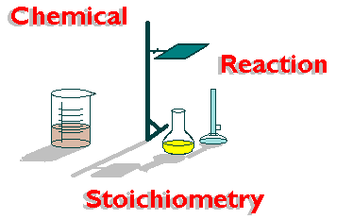

Chemical Synthesis
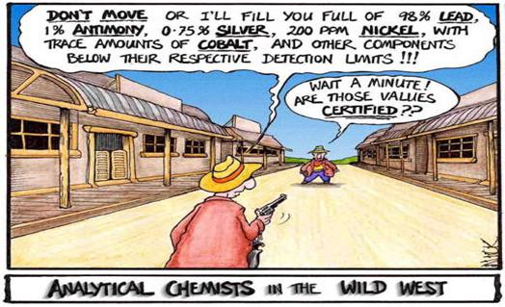

Significant Figures and uncertainties

- Use scientific notation for very large and very small numbers.
  - 0.0056 = 5.6 x 10⁻³, 167,000 = 1.67 x 10⁵

    - Express the following in scientific notation.
- 6409 c) 891 000
- 0.032 d) 0.000 006 1

    - How many significant figure are in the following?
- 649 c) 891 000
- 0.032 d) 0.000 006 1

- Any measurement made using scientific equipment will have some uncertainty associated with it.
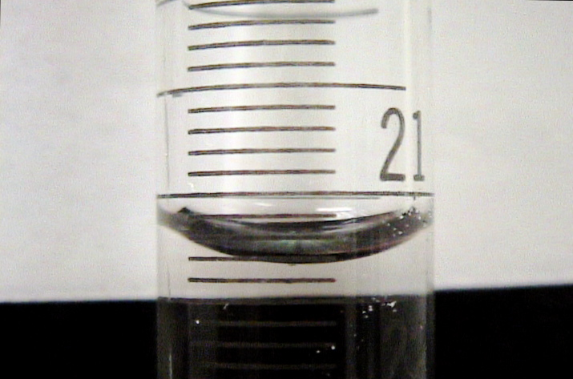
  - The meniscus in the diagram tells us the volume of liquid in the burette.

    - What is the reading on the burette?

    - An investigator reported that liquid was escaping from a factory. He measured the amount lost over an hour and recorded 36 671 L. He realised that this measurement involved some uncertainties like recording time and volume. He also thought that the amount might be slightly different each hour. He concluded that the amount escaping each hour was 36 670 ± 150 L. What is the percentage uncertainty of this result?

    - Divide 6.8245 by 1.13 and express your answer to the correct number of sf.

    - In processing the results of an experiment, a student’s final calculation is

$$\frac{0.574862 × 100}{156.0 × 16.1}$$

What answer should he write down?

    - 2.445 g of anhydrous sodium is dissolved in distilled water in a 250 mL volumetric flask. The mass has an uncertainty of ± 0.005 g and the flask has an uncertainty of ± 0.3 mL. Calculate the concentration in g/L and the percentage and absolute uncertainties.

PC 19.3 p525-7 19.3 Review p 527 EC p224

EQUATIONS

Memorise these reactions.

SOME COMMON ACID / BASE REACTIONS

Acidic solutions dissolve most metals (Pb, Sn, Ni, Co, Cd, Fe, Cr, Zn, Mn, Al, Mg, Na, Ca, Sr, Ba, K, Li).
ACID + METAL → SALT + H₂ _{(g)}
Example: Solid nickel treated with hydrochloric acid solution.
Ni _{(s)} + 2HCl _{(aq)} → NiCl₂ _{(aq)} + H₂ _{(g)}
Ni _{(s)} + 2H⁺ _{(aq)} → Ni²⁺ _{(aq)} + H₂ _{(g)}

Acidic solutions react with all carbonate and hydrogencarbonate compounds.
ACID + CARBONATE or → SALT + H₂O _{(l)} + CO₂ _{(g)}
HYDROGENCARBONATE
Example: Hydrochloric acid is added to solid nickel carbonate.
NiCO₃ _{(s)} + 2HCl _{(aq)} → NiCl₂ _{(aq)} + H₂O _{(l)} + CO₂ _{(g)}
NiCO₃ _{(s)} + 2H⁺ _{(aq)} → Ni²⁺ _{(aq)} + H₂O _{(l)} + CO₂ _{(g)}

Acidic solutions react with all metal hydroxides.
ACID + METAL HYDROXIDE → SALT + H₂O _{(l)}
Example: Solid calcium hydroxide is added to a nitric acid solution.
Ca(OH)₂ _{(s)} + 2HNO₃ _{(aq)} → Ca(NO₃)₂ _{(aq)} + H₂O _{(l)}
Ca(OH)₂ _{(s)} + 2H⁺ _{(aq)} → Ca²⁺ _{(aq)} + H₂O _{(l)}

• Acid solutions react with ammonia (NH₃) solution to form ammonium ions (NH₄⁺).
ACID + AMMONIA SOLUTION → AMMONIUM IONS
Example: Ammonia is added to hydrochloric acid solution
HCl _{(aq)} + NH₃ _{(aq)} → NH₄Cl _{(aq)}
H⁺ _{(aq)} + NH₃ _{(aq)} → NH₄⁺ _{(aq)}

Acidic solutions react with all metal oxides.
ACID + METAL OXIDE → SALT + H₂O _{(l)}
Example: A sulfuric acid solution is added to solid copper (II) oxide.
H₂SO₄ _{(aq)} + CuO _{(s)} → CuSO₄ _{(aq)} + H₂O _{(l)}
2H⁺ _{(aq)} + CuO _{(s)} → Cu²⁺ _{(aq)} + H₂O _{(l)}

Basic solutions react with non-metal oxides (acidic oxide) producing a salt and water.

OH⁻ + NON-METAL OXIDE → SALT + H₂O _{(l)}
Example: Sulfur dioxide gas is bubbled through a potassium hydroxide solution.

SO₂ _{(g)} + 2KOH _{(aq)} → K₂SO₃ _{(aq)} + H₂O _{(l)}
SO₂ _{(g)} + 2OH⁻ _{(aq)} → SO₃²⁻ _{(aq)} + H₂O _{(l)}

Acidic oxides and the anions they form in basic solutions:
Acidic Oxide | Anion Formed
CO₂ Carbon dioxide | CO₃⁻² Carbonate ion
SO₂ Sulfur dioxide | SO₃⁻² Sulfite ion
SO₃ Sulfur trioxide | SO₄⁻² Sulfate ion
NO₂ Nitrogen dioxide | NO₃⁻¹ nitrate ion and NO₂⁻¹ nitrite ion

Worth knowing

Basic solutions react with ammonium salts producing a salt, water and ammonic gas.

OH⁻ + AMMONIUM SALT → SALT + H₂O _{(l)} + NH₃ _{(g)}

Example: Ammonium chloride solution is added to a potassium hydroxide solution.
NH₄Cl _{(aq)} + KOH _{(aq)} → KCl _{(aq)} + H₂O _{(l)} + NH₃ _{(g)}
NH₄⁺ _{(aq)} + OH⁻ _{(aq)} → H₂O _{(l)} + NH₃ _{(g)}

Acidic solutions react with metal sulfites to producing a salt, water and sulfur dioxide gas.
ACID + METAL SULFITE → SALT + H₂O _{(l)} + SO₂ _{(g)}
Example: Sodium sulfite solution and hydrochloric acid solution are mixed.
Na₂SO₃ _{(aq)} + 2HCl _{(aq)} → NaCl _{(aq)} + H₂O _{(l)} + SO₂ _{(g)}
SO₃²⁻ _{(aq)} + 2H⁺ _{(aq)} → H₂O _{(l)} + SO₂ _{(g)}

Acidic solutions react with all metal sulfides producing a salt and hydrogen sulfide gas.
ACID + METAL SULFIDE → SALT + H₂S _{(g)}
Example: A nitric acid solution is mixed with a potassium sulfide solution.
2HNO₃ _{(aq)} + K₂S _{(aq)} → KNO₃ _{(aq)} + H₂S _{(g)}
2H⁺ _{(aq)} + S²⁻ _{(aq)} → H₂S _{(g)}

Problem Set 1 Answers page 55
1. Several experiments are described below. In each case a chemical reaction will occur. Write a balanced molecular equation to show this and give a short description of what you would expect to observe as the reaction occurs.
- Excess HNO₃ _{(aq)} solution is added to solid Fe₂(CO₃)₃.

- Granule of calcium oxide is treated with excess HCl _{(aq)} solution.

- Excess HNO₃ _{(aq)} solution is added to a iron (II) hydroxide suspension.

- Dilute KOH _{(aq)} is added to an NH₄NO₃ _{(aq)} solution.

- Some 2.0 mol L⁻¹ sulphuric acid is added to solid iron metal.

- Solid calcium hydroxide pellets are added to excess phosphoric acid.

- Solid potassium sulfite granules are added to a hydrochloric acid solution.

- Concentrate ethanoic acid is added to solid nickel (II) carbonate.

- Sulfur dioxide gas is bubbled through a potassium hydroxide solution.

- Sulfur trioxide gas is passed through a barium hydroxide solution.

- Aluminium is added to a solution containing excess sulfuric acid.

- Most of the following experiments will result in a chemical change. Where this is expected write a balanced net ionic equation that shows this. Also describe any observable changes you would expect to see during the progress of the reaction. If no change is expected write no reaction.

- Powder CuO is added to a H₂SO₄ solution.

- A barium hydroxide solution is added to a copper (II) carbonate suspension.

- Sulphur dioxide gas is bubbled through a potassium hydroxide solution.

- Powdered ammonium nitrate is added to excess sodium hydroxide solution.

- Powder calcium hydroxide is added to a concentrated sodium hydroxide solution.

- A sodium sulfite solution is added to a nitric acid solution.

- Granulate zinc is added to hydrochloric acid.

- A sulfuric acid solution is added to a copper (II) hydroxide suspension.

- The table shows observations recorded when tests are carried out on four samples of a solution. Use these results to deduce the ions present. Support your deduction with an ionic equation.
Test | Result | Ions present and equation
add KI | Yellow ppt
Add drops of OH⁻ | Blue ppt
Add AgNO₃ | white ppt that darkens on exposure to light
Add dilute HCl | gas produced that turns limewater milky

Problem Set 2 Answers at back of book (page 49)

- A few drops of dilute sodium hydroxide solution is added to the following. Does a precipitation reaction occur in any of these situations? If a reaction is expected write a net ionic equation to show this and describe any observation you would expect.

- SnCl₂ _{(aq)}

- Na₂SO₄ _{(aq)}

- barium chloride solution

- Fe(NO₃)₃ _{(aq)}

- copper (II) sulfate solution

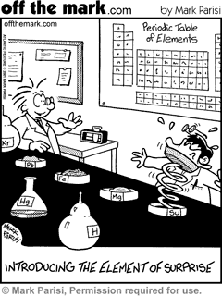
- The following ionic solutes may or may not be soluble. Where soluble, write dissociation equations to show how they dissolve to form aqueous solutions.

- FeCl_{2 (s)}

- MgCO_{3 (s)}

- Ba(OH)_{2 (s)}

- (NH₄)₃PO_{4 (s)}

- Ca(OH)_{2 (s)}

- Using precipitation reactions and reagents of your choosing show how to distinguish each substance in the following groups of three compounds. You will need to explain your process in written form or by using a flow diagram. You may need to perform more than one test for each group of unknowns. Remember, to perform a precipitation reaction, the substance tested must first be in solution.

NB: there are other methods than the ones listed below.

  - Na₂SO_{4 (s)}, Na₂CO₃ _{(s)} and NaOH_{(s)}

  - Pb(NO₃)_{2 (s)}, Fe(NO₃)_{2 (s)} and Mg(NO₃)_{2 (s)}


Working with numbers in calculations

Scientific Notation
- also called exponential notation.
- used to express very large or very small numbers.
- written as a number between 1 and 10 multiplied by a power of ten.
For example,
0.056 = 5.6 x 10⁻² moving decimal to right
0.0000879 = 8.79 x 10⁻⁵ results in –ve power of ten

167000 = 1.67 x 10⁵ moving decimal to left
892 = 8.92 x 10² results in +ve power of ten

Significant Figures
- gives an indication of the accuracy of measurement.
- includes digits which are known for certain plus one uncertain digit.
- 342, 8.14 and 2.52 x 10³ all have 3 sig. figs.
- any zeros
  - between a decimal point and the first non-zero number are not significant.
For example, 0.0001 has 1 sig. fig., 0.025 has 2 sig. figs.
  - between non-zero numbers are significant.
For example, 203 has 3 sig. figs., 7026 has 4 sig. figs.
  - following non-zero numbers have unknown significance.
For example, 350 could have 2 or 3, 7900 could have 2,3 or 4.
- when multiplying or dividing numbers, the number of sig. figs. in the answer has to be the same as that in the least accurate number.
3.216 x 11 = 3.5 not 3.5376
2.309 ÷ 1.07 = 2.16 not 2.1579
- when adding and subtracting, the answer has to be as accurate as the least accurate number (least number of decimal points).
8.756 – 1.62 = 7.14 not 7.136 (1.62 is accurate to 2 dp’s)
2.3 + 2.79 + 1.274 = 6.4 not 6.364 (2.3 is accurate to 1 dp)
- when rounding off to the appropriate number of sig. figs.
  - choose the nearest number to the last digit. For example
7.609 becomes 7.61 to 3 sig. figs.
4.533 becomes 4.53 to 3 sig. figs.
  - if 5 has to be rounded off, choose the nearest even number
8.25 becomes 8.2 to 2 sig. figs.
2.375 becomes 2.38 to 3 sig. figs.
- in large calculations do not round off till the very last step.
- numbers should be expressed in scientific notation to make clear the number of significant figures.
350 = 3.5 x 10² has 2 sig. figs.
3700 = 3.70 x 10³ has 3 sig. figs.

HOWEVER: All final answers in Year 12 must be expressed to the appropriate number of significant figures (usually three) and include units where applicable.
STOICHIOMETRY

Stoichiometry is the process of calculating the amount of reactants needed or products made by a chemical reaction. Fortunately, all stoichiometry problems follow the same steps.

A stoichiometric calculation cannot be attempted without first writing a balanced chemical equation. This equation shows the relationship between the number of moles of reactants and the number of moles of products.

The following general points are relevant to all calculation types:

- Clarity of presentation is paramount. The examiner must be able to follow the logic of the solution.

- All working should be clearly shown.

- All answers must be expressed to three significant figures and include units where applicable.

- Scientific quantities have dimensions and these should be shown.

- Marks are allocated for the steps involved in solving the problem (not just the final answer), so the examiner must be able to easily follow the solution presented.

REACTING QUANTITIES

Relative Atomic Mass (A_{r})

- It is the mass of an atom of an element compared to the carbon-12 atom.

- It can be defined as the relative average mass of the element on a scale on which the mass of atoms of the isotope ¹²C is exactly 12.

Relative Molecular Mass (M_{r})

- Relative molecular mass is the mass of the molecule of a substance compared to ¹/₁₂ of the mass of a ¹²C atom.

- The symbol is M_{r}.

- M_{r} is the sum of the relative atomic masses of its constituent atoms.

eg M_{r}(O₂) = 2 A_{r}(O) = 2 x 16.00 = 32.00

M_{r}(H₂O) = 2A_{r}(H) + A_{r}(O) = 2.016 + 16.00 = 18.016

M_{r}(C₂H₄O) = 2A_{r}(C) + 4 A_{r}(H) + A_{r}(O) = 24.02 + 4.032 + 16.00 = 44.232

The Mole Concept

- The MOLE is a number. It is equal to the number of atoms in exactly 12g of carbon ¹²C.

- This number is called Avagadro’s Constant and has the symbol N_{A}.

N_{A} = 6.022 x 10²³

- A mole of any element is the amount of it in a sample whose mass in grams is numerically equal to the relative atomic mass of that element.

- Symbols n = number of moles
mol = abbreviation for the unit mole.

- Thus the system used to abbreviate statements is:- n(Na) = 0.01 mol

- Reads as “the amount of sodium (number of moles of sodium) is 0.01 moles”.

Molar Mass

- The molar mass is the mass in grams of a mole of a substance. Symbol is M and the unit is g/mol or g mol⁻¹.

e.g. M(Cu) = 63.5 g mol⁻¹
M(S) = 32.1 g mol⁻¹

- mass of a substance (m) = amount in moles x molar mass.

i.e. m = n x M

This can be adapted to

ie number of moles (n) = mass of substance(g)
mass of 1 mole

- A mole of a molecular substance is the amount (number of particles) whose mass in grams is numerically equal to its relative molecular mass. The molar mass of a molecular substance is numerically equal to its relative molecular mass.

i.e. Molar Mass = M_{r} expressed in grams.

- Another relationship which is useful is:-

n = N = N .
N_{A} 6.022x10²³

where N = the number of particles.

- Useful Formulae

MASS  (m) |  | MOLES  (n) |  | VOL of gas at STP
 |  | VOLUME of solution |  | VOL of gas not at STP

R = 8.314 (P in kPa)

STP: 273.15 K and 100.0 kPa

The steps in working out any mole calculations in a reaction is as follows:

- Write a balanced equation (you can leave out the states at this stage). Indicate all known quantities and use a (?) for the unknown.

- Calculate n(known), using ; ; ; n= cV.

- Determine n(unknown), using mole ratio from the balanced equation.

ie. n(unknown) = mol equivalent of unknown x n(known)
mol equivalent of known

- Convert n(unknown) to the format required by the question.
ie. m(unknown) = nM ; V(unknown gas) = n x 22.71 or ;

You have to adjust these steps to suit the specific question!

Calculations involving mass and mole
NB: It is advisable to use molecular equations when doing calculations.

Example #1

When excess barium nitrate solution was added to an aluminium sulphate solution, 6.260 g of barium sulphate was recovered. Calculate the mass of aluminium sulphate in the original solution.

Example #2

Determine the mass of carbon dioxide released into the atmosphere when 1.00 kg of petrol is completely burnt in oxygen. Assume petrol to be octane, C₈H₁₈.

Calculations involving gases in chemical change

Assumptions on which the kinetic theory of gases is based includes:
- Gases consist of tiny particles called molecules, except for the noble gases – these consist of atoms.
- Average distance between the molecules of a gas is very large compared to the size of each gas molecule.
- The molecule move in rapid, random, straight-line motion which results in collision with each other and the sides of the container.
- The molecules exert negligible attractive or repulsive force on one another.
- Average kinetic energy of the molecules increases with temperature.
- All collision of gas molecules is perfectly elastic.
Gases which obey all the assumptions of the theory are known as ideal gases.
Absolute zero temperature
- The temperature at which a gas occupies a volume of zero is –273.15 °C, absolute zero.
- The Kelvin scale of temperature; 0 K is equal to –273.15 °C.
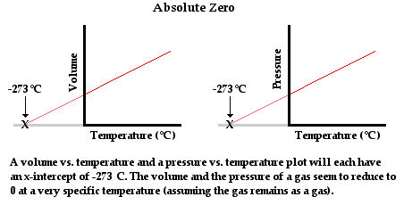

Standard Temperature and Pressure
- Since the volume of a gas varies with temperature and pressure, some sort of standard is needed for the purpose of comparison. The name of these conditions is known as STP – Standard Temperature and Pressure: the conditions of STP include:
Pressure: 100 kPa
Temperature: 0 °C or 273.15 K

- Water at STP will be a __________________ because _________________________

- Amount of gas used or produced during a chemical change is most easily found by measuring its volume.
- Units of volume are the litre (L).
- When dealing with gas laws, we assume that the gases considered are ideal gases – gases that meet the assumptions of the kinetic theory.
- Moles of gas can be found using ideal gas equation. Note, the amount of gas is independent of what the particular gas is.

or PV = nRT where: P = pressure of gas in kPa
V = volume of gas in litres (L)
n = moles of gas (mol)
R = universal gas constant - 8.314 J K⁻¹ mol⁻¹
T = temperature of gas in kelvin (K)

- Temperature and pressure must be in correct units of kelvin (K) and kilopascal (kPa)
- Converting temperature from Celsius to kelvin add 273.15
T(K) = 273.15 + T⁰C
- Converting pressure to kilopascals:
- Pressure can be in atmospheres (atm)
P (kPa) = P (atm) x 100
- Pressure can be in millimetre of mercury (mmHg)
P (kPa) = P (mmHg) x 100
760
Example
- How many moles of oxygen gas can we expect at STP in a 1.5 L container?

T = 273.15 K n = PV
P = 100 kPa RT
V = 1.5 L = 100 x 1.5
R = 8.314 J K⁻¹ mol⁻¹ 8.314 x 273.15
n = ? = 0.0661 mol

- How many moles of water vapour can we expect at STP in a 1.5 L container?

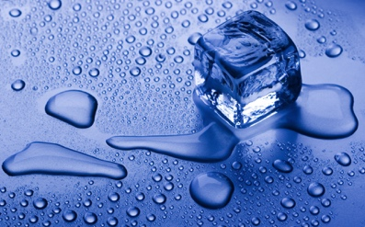

    - In an investigation into the chemical properties of an unknown metal, Peter adds 2.50 g of the metal to excess hydrochloric acid and collects the hydrogen gas liberated from the reaction. How many moles of hydrogen gas are formed if 15.0 mL of it are collected at 102.1 kPa and 23.0 ⁰C?

    - Excess hydrochloric acid (HCl) reacts with a small amount of aluminium foil (Al) forming 3.98 L of hydrogen gas (H₂) measured at 18.0 ⁰C and 103.5 kPa. What mass of aluminium was used in the reaction?

    - Excess aluminium foil is added to a solution containing 5.22 g of hydrochloric acid (HCl). what volume of hydrogen gas can be expected to form when the gas is measured at 155 kPa and 32.0 ⁰C?



Chemical synthesis to form products with specific properties may require the construction of reaction sequences with more than one chemical reaction and involves the selection of particular reagents and reaction conditions in order to optimise the rate and yield of the product.

- Chemical synthesis is the construction of complex chemical compounds from simpler ones.
- It is the process by which many substances important to daily life are obtained.
- It is applied to all types of chemical compounds, but most syntheses are of organic molecules.

- In the process of creating new compounds, careful considerations of the reactions and processes is undertaken to obtain a product, or products.
- This happens by physical and chemical manipulations usually involving one or more reactions.

- Many synthesis reactions involve more than one step.
- Each step has its own reactants, products and activation energy.
- The products of one step are often the reactants of the next step.
- Chemists select factors within each step that allow products to be made as cheaply, safely and efficiently as possible.
EC 15.1 p160-1

MULTISTEP PROCESSES

- Consider the Contact Process in the manufacture of sulfuric acid
- Each step is chosen to produce the acid cheaply, safely and efficiently.

  - Step 1: production of sulfur dioxide

S + O₂ SO₂ or

4FeS₂ + 11O₂ 2Fe₂O₃ + 8 SO₂

  - Step 2: production of sulfur trioxide

2SO₂ + O₂ 2SO₃

  - Step 3: production of sulfuric acid

SO₃ + H₂SO₄ H₂S₂O₇

H₂S₂O₇ + H₂O 2H₂SO₄

- Considerations at each step.
  - Step 1: Air is cheap, provides O₂. Reaction rate increases with high concentration of reactants. = more collisions.
  - Step 2: Reaction is exothermic. Increase temp increases reaction rate but favours endothermic reaction. Compromise temperature of 400-450 °C. High pressure favours both reactions as they are gases (more collisions). High pressure favours side with less molecules, forward reaction. Costly to make high pressure equipment – 1-2 atm used. Catalyst (V₂O₅)used to speed up reaction

- Some problems involve a series of reactions. It is usually best to get an overall equation before proceeding. Alternatively, follow the mole ratios through each reaction.

    - Sulfuric acid can be made from iron pyrites (FeS₂) by a sequence of reactions. Calculate the mass of sulfuric acid produced from 100.0 kg of pure iron pyrites. The process is 100 % efficient.

4FeS₂ + 11O₂ 2Fe₂O₃ + 8 SO₂

2SO₂ + O₂ 2SO₃

SO₃ + H₂O H₂SO₄

- In the blast furnace reduction of iron, pure carbon in the form of coke, C_{(s)}, is reacted with a limited supply of oxygen gas to completely convert the coke into carbon monoxide gas. The carbon monoxide gas then reacts with iron (III) oxide to produce liquid iron and carbon dioxide gas.
The equations for the reactions which occur are shown (not necessarily balanced)

C_{(s)} + O_{2(g)} CO_{(g)}
Fe₂O_{3(s)} + CO_{(g)} Fe_{(l)} + CO_{2(g)}

- Balance and combine the equations to show the correct mole ratio between coke and the iron product.
C_{(s)} + O_{2(g)} CO_{(g)}
Fe₂O_{3(s)} + CO_{(g)} Fe_{(l)} + CO_{2(g)}

C_{(s)} + O_{2(g)} + Fe₂O_{3(s)} Fe_{(l)} + CO_{2(g)}

- Determine the mass of coke which should be added to the blast furnace to react with 1.00 tonne of pure iron (III) oxide.

Quantities of products in a chemical synthesis reaction can be calculated by comparing stoichiometric quantities with actual quantities and by determining the limiting reagent.

Calculations involving limiting reagents

- In most situations where a chemical reaction is performed one of the two reagents will be present in excess, i.e. some of it remains when the reaction is finished.

- The reagent that is fully consumed is known as the limiting reagent.

- When the amount of both reagents is given it is important to determine which of these substances is the limiting agent as the limiting reagent fixes the amount of all other substance used or produced in the reaction.

- One method for identifying the limiting reagent is to compare the stoichiometric and actual ratios of the two reagents.

Example

1.5 kg H₂SO₄ was accidentally spilled on the lab floor. A clever year 12 student immediately realised that she can neutralise it with NaOH. She found 2.00 kg of this base, made a solution and add that to the acid. Let’s assume the reaction was complete.
Determine the limiting reagent and then calculate the mass of the salt that will be produced.

Mass NaOH
Determine limiting reagent Mole Na₂SO₄ Mass Na₂SO₄
Mass H₂SO₄

Step 1: Balanced equation 2NaOH + H₂SO₄ Na₂SO₄ + 2H₂O

Step 2: Calculate the moles of each reactant
n(H₂SO₄) = m = 1.5 x 10³ = 15.3 mol
M 98.076
$$actual ratio= \frac{NaOH}{H_{2}SO_{4}}= \frac{50.0}{15.3}=3.3$$

$$stoich ratio= \frac{NaOH}{H_{2}SO_{4}}= \frac{2}{1}=2$$

since AR >SR, NaOH is excess.

H₂SO₄ is the limiting reagent.

n(NaOH) = m = 2.00 x 10³ = 50.0 mol
M 39.998

Step 3: Compare the mole ratio
2 mol NaOH reacts with 1 mol H₂SO₄
50.0 mol NaOH reacts with 25 mol H₂SO₄

Step 4: Decide the limiting reagent
Need 25 mol H₂SO₄ but only have 15.3 mol
Not enough H₂SO₄ therefore limiting reagent

2NaOH + H₂SO₄ Na₂SO₄ + 2H₂O
2 mol 1 mol 1 mol
Given 50 mol 15.3 mol
Ratio 30.6 mol 15.3 mol 15.3 mol
Excess 19.4 mol 0 mol
LR

Step 5: Identify the unknown and relate it to the limiting reagent
1 mol H₂SO₄ produce 1 mol Na₂SO₄
n(Na₂SO₄) = n(H₂SO₄) = 15.3 mol

Step 6: Convert the moles to mass
m(Na₂SO₄) = n x M
= 15.3 x 142.04
= 2.17 kg

PC 11.2 p 278-1 11.2 Review p 282-3 EC 9.9, 9.10, 9.11 p104-5

- Hydrochloric acid containing 10.0 g of HCl was reacted with 10.0 g of calcium carbonate to produce carbon dioxide gas. Determine:

a. the limiting agent
b. the mass of CO₂ _{(g)} produced.
c. the mass of unused reactant.

- A 3.200 g sample of NaOH is added to a solution containing 1.125 g of H₂SO₄. Determine:

a. the limiting reagent;
b. the mass of sodium sulphate formed in solution;
c. the mass of unused reactant remaining in solution.

The percentage yield of a chemical synthesis reaction can be calculated by comparing theoretical versus actual product quantities

Calculations involving impurities and percentages

- The percentage purity, by mass, of a substance can be calculated using the formula:

% purity of the material = mass of pure substance x 100
mass of impure substance

- The percentage yield of a reaction is a measure of how much product was actually produced compared to the theoretical amount expected to be produced.

% yield of the reaction = mass of product actually obtained x 100
theoretical mass of product expected

EC 9.7, 9.8 p98-9, 15.12 p168

- In an experiment to find the purity of a 5.642 g sample of anhydrous sodium carbonate, it was reacted with excess hydrochloric acid. A volume of 1.170 L of CO₂ gas was collect at STP. Find the purity of the Na₂CO₃ sample.

PC 11.1 p 274-6 11.1 Review p 277

- Sulphuric acid can be manufactured from iron pyrites (FeS₂) by the sequence of reactions shown. Calculate the mass of sulphuric acid which could be obtained from 100.0 kg of pure iron pyrites if the overall process is 85% efficient.
HINT:
- Balance all equations
- Simplify
- Write as one equation
(i) 4FeS₂ _{(s)} + 11O₂ _{(g)} 2Fe₂O₃ _{(s)} + 8SO₂ _{(g)}

(ii) 2SO₂ _{(g)} + O₂ _{(g)} 2SO₃ _{(g)}

(iii) SO₃ _{(g)} + H₂O _{(l)} H₂SO₄ _{(l)}

- Sodium carbonate can be produced by the Solvay process which involved the following reactions:
NH₃ + H₂O + CO₂ NH₄HCO₃
NH₄HCO₃ + NaCl NH₄Cl + NaHCO₃
2NaHCO₃ Na₂CO₃ + H₂O + CO₂
Na₂CO₃ + 10H₂O Na₂CO₃.10H₂O
Assuming the process is 90% efficient, calculate the mass of ammonia and
sodium chloride required to produce 1000 kg of sodium carbonate-10-water.

PERCENTAGE YIELD IN MULTISTEP SYNTHESES

- When a reaction has a number of steps, the overall percentage yield will be reduced at each step.
- The yield for each step has an effect on the overall yield.
- The overall percentage yield is helpful in determining whether a particular pathway is the best way to produce a particular compound.

  - Ethyl ethanoate can be produced from ethene according to the following reaction path:
H₃PO₄
C₂H₄ + H₂O → C₂H₅OH
H₂SO₄
C₂H₅OH + CH₃COOH → CH₃COOCH₂CH₃ + H₂O

- If the percentage yield for the first step is 60% and the percentage yield for the second step is 80%, calculate the mass of ethyl ethanoate that would be produced from 155.0 L of ethene gas, measured at a temperature of 100°C and a pressure of 100 kPa. Give your answer to 3 significant figures.

Percentage purity
- Not all reactions involve reactants that are 100% pure.
- When working with impure reactants, do not convert their masses to moles.
- Usually, work out the amount of product made, work out how much reactant was required, then work out the percentage of reactant used out of the amount given.

- A 154.4 g ore sample containing copper (I) sulphide was roasted in air and 12.25 g of copper were recovered. The equation for the reaction is as follows:

Cu₂S _{(s)} + O₂ _{(g)} 2Cu _{(s)} + SO₂ _{(g)}

Determine the % of copper (I) sulphide in the ore sample.

- Density is simply defined as the mass per unit volume:
p = density
m = mass of solution
V = volume of solution
- Commonly used units are kgm⁻³, g cm⁻³, gL⁻¹, g mL⁻¹.
- Specific gravity is sometimes given instead of density. S.G. is the ratio of a substance’s density compared to that of water.

if S.G. = 1.45
then density = 1.45 g mL⁻¹.

- A car battery contains 4.0 L of sulphuric acid solution. When the battery is fully charged, the acid has a concentration of 4.50 mol L⁻¹ and a density of 1.45 g mL⁻¹. Determine:

a. the mass of H₂SO₄ in the battery.
b. the percentage by mass of H₂SO₄ in the acid solution.

- A solution of copper (II) nitrate is made up by dissolving 25.15 g of the solid in water and making the solution up to 500.0 mL. Determine the concentration of the:

a. Cu(NO₃)₂ solution.
b. Cu⁺² _{(aq)} and NO₃⁻ _{(aq)} ions.

- A 10.0 mL sample of battery acid (H₂SO₄) is diluted to 250 mL and then analysed by volumetric analysis. The diluted acid was found to have a concentration of 0.175 mol L⁻¹.

a. Determine the concentration of the battery acid in:
(i) mol L⁻¹
(ii) g L⁻¹

b. Given that the density of the battery acid was found to be 1.45 g mL⁻¹, determine
the % by mass of H₂SO₄ in battery acid.

- A 1.250 g sample of NaCl is dissolved in 75.0 mL of water. To this solution 25.0 mL of 0.615 mol L⁻¹ AgNO₃ solution is added. Find:

a. mass of silver chloride produced.
b. concentration of any remaining ions in mol L⁻¹.

- When 20.0 mL of 0.450 mol L⁻¹ NaOH solution is mixed with 30.0 mL of 0.540 mol L⁻¹ magnesium chloride solutions, a precipitate of magnesium hydroxide is produced. Calculate:

a. mass of the precipitate.
b. concentration of any remaining ions.

Problem Set 3 Answers page 59

1. In the blast furnace the reduction of iron, pure carbon in the form of coke, C_{(s)}, is reacted with a limited supply of oxygen gas to completely convert the coke into carbon monoxide gas. The carbon monoxide gas then reacts with iron (III) oxide to produce liquid iron and carbon dioxide gas.

The unbalanced equation is: C _{(s)} + O₂ _{(g)} CO _{(g)} and Fe₂O₃ _{(s)} + CO _{(g)} Fe _{(l)} + CO₂ _{(g)}

a. Balance and combine the two equations to show the correct mole ratio between the coke and iron product.
b. Determine the mass of coke required to reduce all the iron (III) in 3.00 tonnes of ore which is known to be 35.0% iron (III) oxide by weight.

2. Solid ammonium nitrite heated strongly in the absence of air decomposed into nitrogen gas and water vapour. In an experiment 153.5 g of the compound was heated as described above.
a. Write a balanced equation for the above reaction and calculate the total volume of the gas mixture measured at 120 ºC and 90.0 kPa.

b. The gases are then bubbled through concentrated sulfuric acid to remove all the water vapour. Calculate the final volume of the gas if the measurement takes place at STP.

3. A chemist is required to investigate a sample of water taken from the waste outlet of a chemical plant to determine the cadmium ion concentration of the water. The chemist check her data book and notes that cadmium sulfide and cadmium oxalate both have negligible solubility in water.

She first adds excess sodium oxalate solution to 500.0 mL of the seawater to precipitate all the cadmium ions as cadmium (II) oxalate. It may be assumed that no other metal oxalate is precipitated in this process. She then filters, dries and weighs the precipitate and finds it mass to be 0.501 g.

- From the above data, determine the concentration of cadmium ions in the water sample on both ppm (parts per million) and moles per litre.

In a second procedure, another 500.0 mL sample of water is treated with excess sodium sulfide solution to precipitate all the cadmium ions present as cadmium sulfide. The pure cadmium sulfide is then heated in a test tube over which hydrogen gas is passed, converting all the sulfur in the compound to hydrogen sulfide gas. After treatment to remove any residual hydrogen gas, it was found that the hydrogen sulfide gas occupied 56.0 mL at STP.

b. Determine from the second procedure, the concentration of cadmium ions in the water.

c. Comment on whether the two analytical procedures have yielded results consistent with the experiment measurements taken.

4. In the blast furnace the reduction of iron, pure carbon in the form of coke, C _{(s)}, is reacted with a limited supply of oxygen gas to completely convert the coke into carbon monoxide gas. The carbon monoxide gas then reacts with iron (III) oxide to produce liquid iron and carbon dioxide gas. Calcium carbonate is also added to the blast furnace to produce calcium oxide, which then reacts with the silicon dioxide to produce calcium silicate.

The (not necessarily) balanced equations for the reactions which occur are:

C _{(s)} + O₂ _{(g)} CO _{(g)}
Fe₂O₃ _{(s)} + CO _{(g)} Fe _{(l)} + CO₂ _{(g)}
CaCO₃ _{(s)} CaO _{(s)} + CO₂ _{(g)} and
CaO _{(s)} + SiO₂ _{(s)} CaSiO₃ _{(l)}

a. Balance and combine the first two equations to show the correct mole ratio between the coke and iron product.
b. Determine the minimum mass of coke which should be add to the blast furnace to react with 1.00 tonne of iron ore which has an assay of 93.0 % iron (III) oxide by mass.
c. Assuming that the remaining 7.00% of the ore is silicon dioxide, determine the minimum mass of pure limestone (calcium carbonate) which must be added to 1.00 tonne of the same ore to remove all the silicon dioxide.

5. The production of the fertiliser, di-ammonium hydrogenphosphate, (NH₄)₂HPO₄, from rock phosphate (impure calcium phosphate) can be represented by the following reaction sequence.
Ca₃(PO₄)₂ _{(s)} + 3H₂SO₄ _{(aq)} 2H₃PO₄ _{(aq)} + 3CaSO₄ _{(s)}
H₃PO₄ _{(aq)} + 2NH₃ _{(g)} (NH₄)₂HPO₄
a. A particular sample of rock phosphate weighing 60.0 kg yielded 46.12 kg of di-ammonium hydrogenphosphate. Calculate the percentage of calcium phosphate in the rock phosphate deposit. Assume 100 % efficiency in the process.
b. What volume of ammonia gas at STP would be needed to bring about the above conversion, given that 10.0 % by volume of the ammonia gas escapes and it not used in the process.

Reagents and reaction conditions are chosen to optimise yield and rate for chemical synthesis processes, including in the production of ammonia (Haber process), sulfuric acid (Contact process) and biodiesel (base-catalysed and lipase-catalysed methods).

Yield

- When performing calculations, it is often assumed that all reactants are consumed to form products.
- In reality, this does not always occur.
  - The process might not be 100% efficient.
  - The reaction might come to equilibrium.
  - The reaction might be slow and not reach completion.
  - Removal of products (separation) might not be 100% efficient.

- The amount of product that is actually produced is referred to as the yield.
- High yield result in large amounts of product.

- In industry, it is desirable to obtain high yields.
- Conditions need to be selected so the equilibrium is pushed as far as possible to the right hand side of an equation.
- Reactants products.
- Factors that can enhance this include:
  - Removal of products.
  - Recycling unused reactants.
  - Selecting an appropriate temperature – favouring the forward reaction.
  - Selecting an appropriate pressure for gaseous reactants – favouring the forward reaction.
  - Selecting an appropriate catalyst.

- Not only is it desirable to increase yield.
- Conditions should be selected to maximise the rate of reaction.
- Save time and money.

- Sulfuric acid is made in the Contact Process. To maximise the yield of sulfuric acid, various conditions need to be carefully considered.

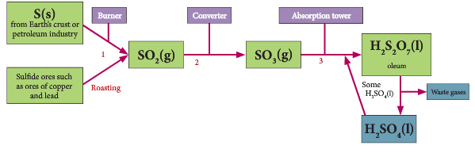
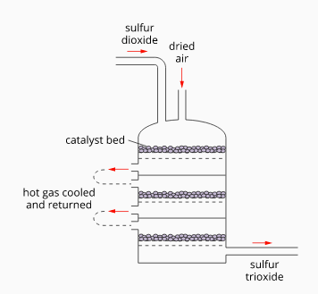
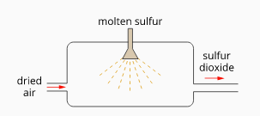
S_{(l)} + O_{2 (g)} SO_{2 (g)} SO_{2 (g)} + O_{2 (g)} SO_{3 (g)}
ΔH = -297 kJ mol⁻¹ ΔH = -197 kJ mol⁻¹

  - Pressure
    - High pressure is not used in the Contact process as the cost of maintaining a high pressure outweighs the benefits of a faster reaction rate and yield of SO3.
    - Atmospheric pressure is used instead.

  - Temperature
    - High temperature increases the reaction rate but favours the reverse reaction.
    - A moderate temperature of 400 - 500°C is used.
    - This ensures a high enough reaction rate while producing a reasonable yield.

  - Catalyst
    - A vanadium (V) oxide (V2O5) catalyst is used.

PC 11.3 p 287-91

- Ammonia is made in the Haber Process
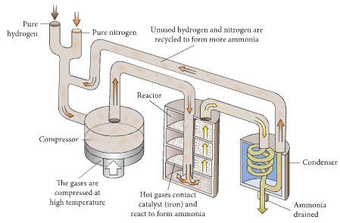
  - N_{2(g)} + 3H_{2(g)} 2NH_{3(g)}
ΔH = -92.4 kJ mol⁻¹

  - Temperature
    - Increased temperature favours rate of reaction – more collisions, more energy.
    - Reaction is exothermic – low temperatures favour forward reaction.
    - Cost – high temperatures increase expenses.
    - Compromise is made between rate, yield and cost
    - 400 – 500 °C ensure adequate ammonia is made in adequate time.

  - Pressure
    - Increased pressure increases rate of reaction.
    - Increased pressure favours side with less particles – RHS.
    - Cost – high pressure equipment is expensive and risky
    - 200 atm is a compromise between rate, yield and cost.
  - Catalyst
    - More particles have energy above E_{a} – sufficient to react.
    - Does not effect yield but will increase rate of reaction.
    - Iron/iron oxide catalyst is used.

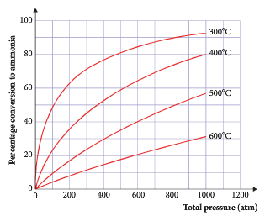

PC 11.3 p 284-7 11.3 Review p 292-3 EC 15.9, 15.10 p165-7

Biodiesel production

- Biofuels are a type of fuel that are derived through biological, rather than geological, processes. They are considered renewable.
- Biodiesel can be manufactured from vegetable oils, animal fats, algae or recycled restaurant greases.
- The production process, called esterification, converts oils or fats into chemicals called long-chain mono alkyl esters. Sodium hydroxide can be used as a catalyst – base-catalysed esterification.
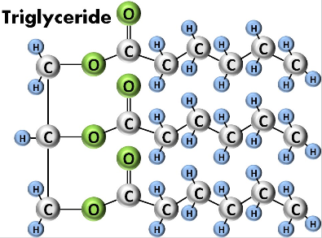
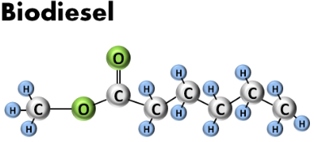
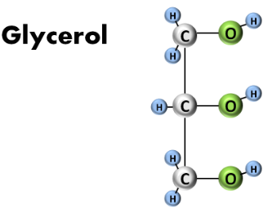
Methanol
+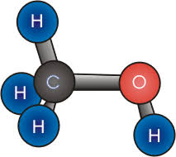
+

ESTER

- When the alkyl chain alcohol is methanol (most common), these are called fatty acid methyl esters.
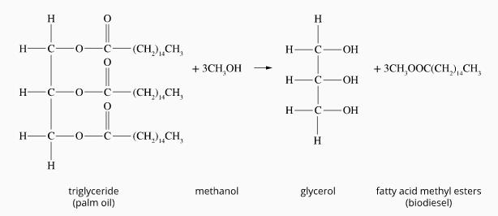
- The triglyceride is converted into biodiesel by warming it with an alcohol (usually methanol) in aprocess called transesterification. This process converts each triglyceride into three molecules of fatty acid esters and glycerol.
- The methanol used is usually manufactured from crude oil, reducing the renewability of the biodiesel.

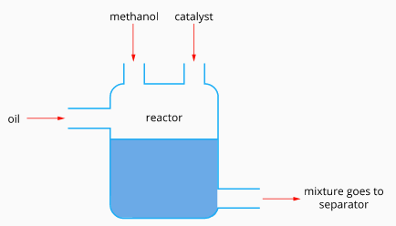
Industrial production of biodiesel

- The triglyceride, methanol and a catalyst are added to the reactor in a batch process. The mixture is gently heated and left for at least 30 minutes.
- The mixture of glycerol and methyl esters separates into two distinct layers.

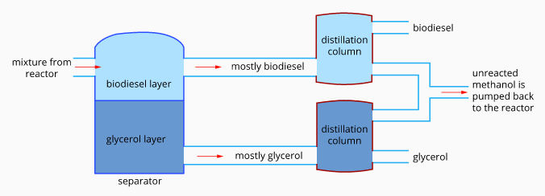

- Roughly speaking, 100 kg of oil or fat are reacted with 10 kg of a short-chain alcohol (usually methanol) in the presence of a catalyst (usually sodium hydroxide [NaOH] or potassium hydroxide [KOH]) to form 100 kg of biodiesel and 10 kg of glycerin (or glycerol).
- The glycerol is about 80% pure.
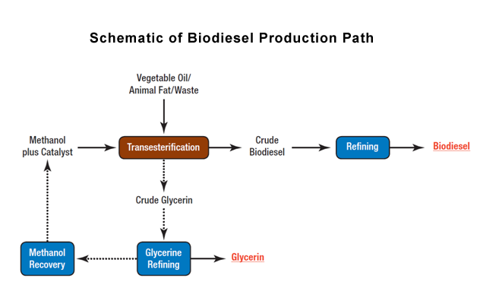
- This process can also be catalysed with an enzyme called lipase – lipase-catalysed esterification. The lipase allows the process to occur at normal temperatures and pressures, making it a much cheaper process.

    - Biodiesel is made by esterification reactions between oils and alcohols
Outline the conditions that need to be considered to maximise the yield of biodiesel.

Comparing base-catalysed and lipase catalysed production

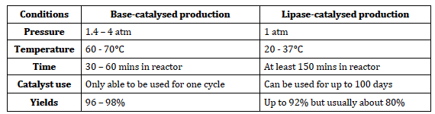

PC 16.4 p 447-52 16.4 Review p 453

Green Chemistry

- During industrial processes (such as the production of ethanol and biodiesel) many considerations are made including
  - designing alternative chemical synthesis pathways.
  - taking into account sustainability.
  - using local resources.
  - economics and environmental impacts (green chemistry).

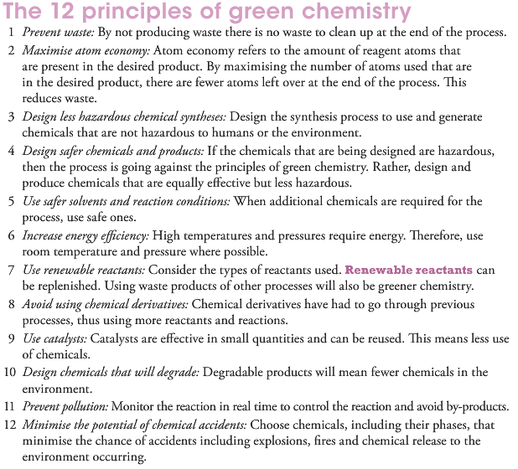

PC Chapter 12 p297-308 EC 15.2 p161, 15.6, 15.7 p163-5

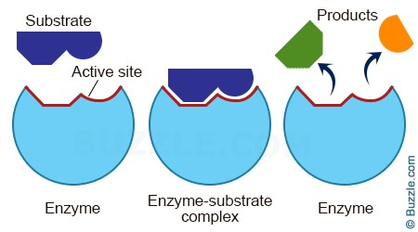
Enzymes are protein molecules which are biological catalysts and can be used on an industrial scale to produce chemicals that would otherwise require high pressure or temperature conditions to achieve an economically viable rate, including fermentation to produce ethanol versus hydrolysis of ethene.

Enzymes as catalysts

- Enzymes are known to catalyse more than 5,000 biochemical reaction types.
- Most enzymes are proteins. They are biological catalysts.
- Enzymes' specificity comes from their unique three-dimensional structures.
- Since they catalyse only specific reactions, unwanted side reactions are eliminated.
- Like all catalysts, enzymes increase the rate of a reaction by lowering its activation energy.
- Enzymes can also be used in industrial processes.
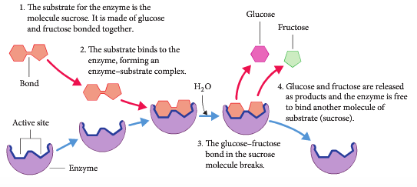
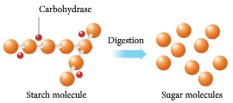

Ethanol production

- Ethanol is used in fuels and in alcoholic drinks.
- It can be produced by fermentation of sugars or by the hydration of ethene.

- Fermentation
  - Grains containing starch or fruits containing sugars, are crushed.
    - Enzymes are used to convert starch and sucrose polysaccharides to glucose and fructose – monosaccharides.
    - This would normally require much energy.
  - Yeast is added.
  - Air is excluded.
  - Mixture kept at 37 °C (yeast is a living thing).
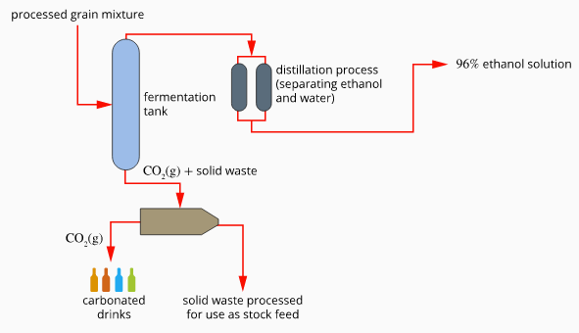
  - C₆H₁₂O₆ 2C₂H₅OH + 2CO₂

- Addition of ethene
  - Most common method of making ethanol.
  - Ethene is a cheap raw material. Produced by cracking of larger hydrocarbons.
  - Ethanol is produced by an addition reaction and the hydrolysis of water.
  - CH₂=CH_{2(g)} + H₂O_{(g)} CH₃CH₂OH_{(g)}
  - High yields are favoured by low temperatures. Low temperatures lower the rate of reaction.
  - A moderate temperature of 270 – 300 °C is used.
  - Catalysts are used – phosphoric acid.
  - High pressure used – 6000 – 7000 kPa.
    - High cost of maintaining high pressure is outweighed by increase in yield and rate.

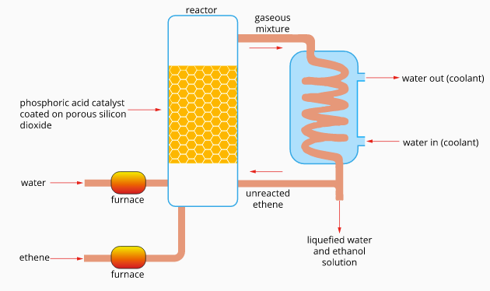

Comparing fermentation and hydration of ethene

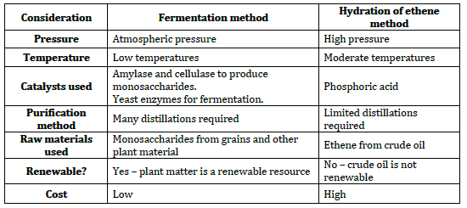

PC 18.4 p 504-8 18.4 Review p 508 Chapter review p509-10 EC 15.3, 15.4, 15.5 p161-3

Chemical synthesis processes may involve the construction of reaction sequences with more than one chemical reaction, including the hydrolysis of ethene to form ethanol and the subsequent reaction of ethanol with acetic (ethanoic) acid to produce ethyl ethanoate.

Reaction sequences

- During the production or synthesis of some chemical compounds it is possible to have several separate steps occur.
- A synthesis is a series of two or more reactions designed to obtain a specific final product.
- Each step can involve a single reaction that must be conducted separately from others in the synthesis.
- Each step needs to be designed efficiently to increase yield and rate of reaction.

Production of ethyl ethanoate

- Ethyl ethanoate is used primarily as a solvent, being favoured because of its low cost, low toxicity, and agreeable odour.
- It is commonly used to clean circuit boards and in some nail varnish removers (acetone and acetonitrile are also used).
- Coffee beans and tea leaves are decaffeinated with this solvent
- It is also used in paints as an activator or hardener.
- Ethyl ethanoate is present in confectionery, perfumes, and fruits. In perfumes, it evaporates quickly, leaving only the scent of the perfume on the skin.

- In the laboratory, mixtures containing ethyl ethanoate are commonly used in column chromatography and extractions.

- A number of new technologies have been commercialised. One company employs a process that uses ethylene and acetic acid with a solid acid catalyst. This process is targeted at locations where competitive ethanol is not available for esterification.

Step 1 – Hydrolysis of ethene to form ethanol

- Ethene comes from fractional distillation of crude oil.
- Ethene is mixed with steam and passed over a catalyst of solid silicon dioxide coated with phosphoric acid.
- Temperatures of 300 °C are used and pressures of about 60 to 70 atm are used.
_{(H3PO4)}
CH₂=CH₂ + H₂O 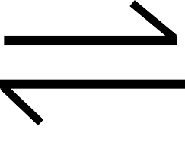 CH₃CH₂OH_{(g)} ΔH = -45 kJ mol⁻¹
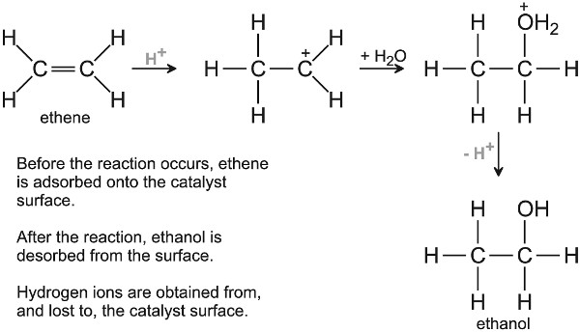
  - Low temp favours
  - High temp favours rate.
  - Compromise of 300 °C.
  - High pressure favour rate and .
  - High pressure are expensive and produce polyethene. Fairly high pressure used.
  - Remove ethanol as it is produced.
  - Recycle unused gases.
  - Water in gaseous phase. High SA = high rate of reaction.
  - Catalyst used.
Step 2 – Oxidation of ethanol to from ethanoic acid

- Ethanol can be oxidised into ethanoic acid using acidified dichromate.
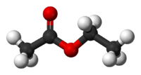
_{Cr2O7 2-}
CH₃CH₂OH + H₂O  CH₃COOH + 4H⁺

Step 3 – Esterification of ethyl ethanoate (ethyl acetate)

- The main method to manufacture ethyl ethanoate involves the esterification of ethanol with acetic acid. Some is produced by the catalytic condensation of acetaldehyde with alkoxides.

- In the main esterification process, a mixture of acetic acid and ethanol with a small amount of sulphuric acid is preheated and fed to an esterifying column where it is refluxed.

- The mixture removed goes to a second refluxing column where a mixture containing 85% ethyl ethanoate is removed.

- Water is mixed with the distillate after which it separates into two layers. The top layer is fed to a refluxing column from which the residue containing 95% ethyl acetate is distilled to remove any impurities.

CH₃COOH + CH₃CH₂OH  CH₃COOCH₂CH₃ + H₂O
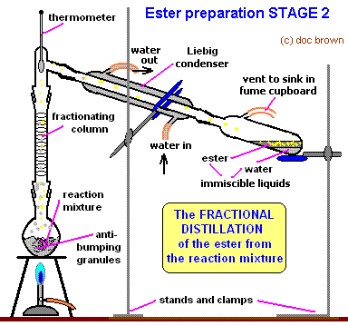

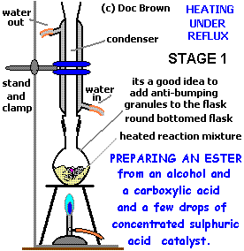

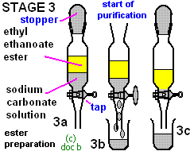

PC 14.4 p 389-93 14.4 Review p 394 EC 15.11 p168

The base hydrolysis (saponification) of fats (triglycerides) produces glycerol and the salt of a long chain fatty acid (soap).

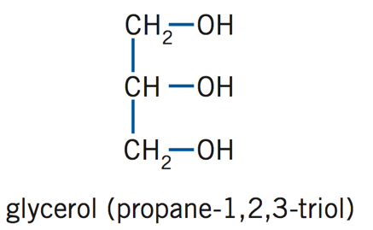
Fats and Oils

- Fats and oils are natural esters of glycerol (or 1,2,3-propantriol).
- Fats are solid at room temperature, oils are liquid at room temperature.

- Long chain carboxylic acids are called fatty acids like

C₁₇H₃₅COOH stearic acid
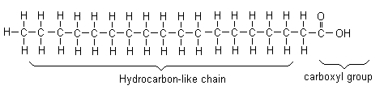

C₁₅H₃₁COOH palmitic acid

or unsaturated fatty acids with double bonds

C₁₇H₃₃COOH oleic acid

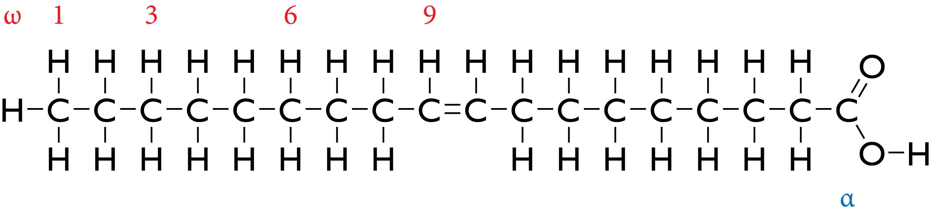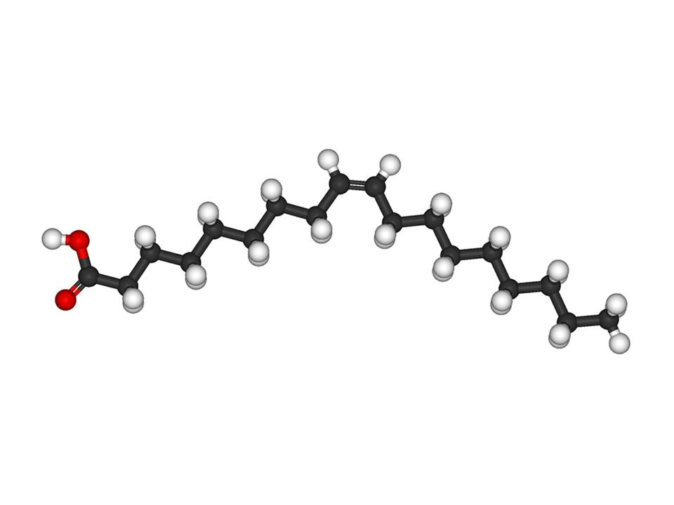

or polyunsaturated with 2 or 3 double bonds

- These fatty acids:
  - Contain unbranched chains of carbons
  - Have between 10 and 20 carbon atoms (mostly even numbers)
  - Have no other functional group present (except carboxylic acid)

Formation of Fats and Oils

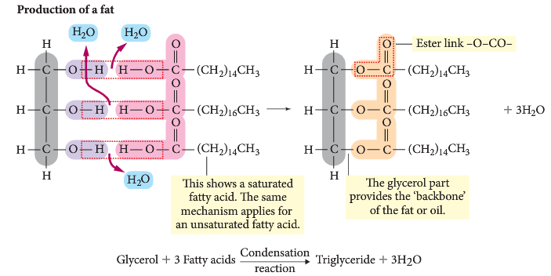
- Animal fats and vegetable oils form when three fatty acids combine with glycerol to form a triester fat.

- An example of the formation of a fat molecule (glycerol tristearate):
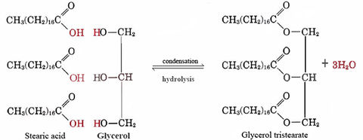

- In this fat (glyceryl tristearate) all three fatty acids are the same (stearic acid). This is not always the case in animal fats and vegetable oil.

- Triglycerides in animal fats are usually saturated (single C-C bonds) and in vegetable oil are usually unsaturated (one or more double bonds)

Animal Fats and Vegetable Oils are Triglycerides

A typical animal fat:

CH₂OOC(CH₂)₁₄CH₃ - saturated palmitate group
|
CHOOC(CH₂)₁₆CH₃ - saturated stearate group
|
CH₂OOC(CH₂)₇CHCH(CH₂)₇CH₃ - unsaturated oleate group

A typical vegetable oil:

CH₂OOC(CH₂)₇CHCH(CH₂)₇CH₃ - unsaturated oleate group
|
CHOOC(CH₂)₇CHCH(CH₂)₇CH₃ - unsaturated oleate group
|
CH₂OOC(CH₂)₆(CH₂CHCH₂)₂(CH₂)₄CH₃ - unsaturated oleate group
- The long hydrocarbon chains of the triglycerides are non-polar so the forces between molecules will be dispersion forces.
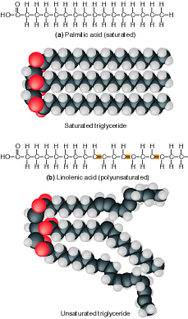


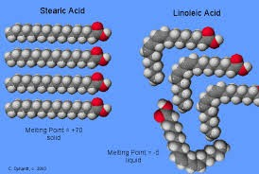
Saturated fat – can pack close. Usually a fat.
Unsaturated fat – can’t pack as close. Usually an oil.

- What will the strength of the dispersion forces depend on? Explain with examples.

- During digestion, the reaction for fat production is reversed and the fats are broken down into glycerol and fatty acids.

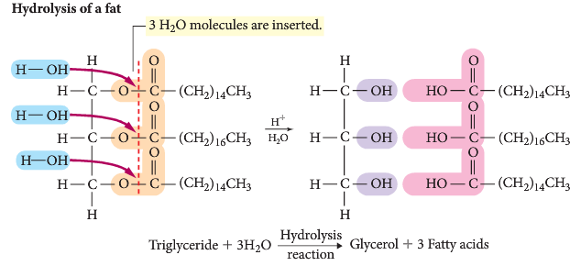

PC 16.1 p 434-6 16.1 Review p 437 EC 11.10 p 124-5

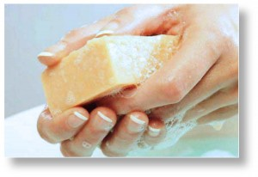
The structure of soaps contains a non-polar hydrocarbon chain and a carboxylate group; the structure of the anionic detergents derived from dodecylbenzene contains a non-polar hydrocarbon chain and a sulfonate group.

Soaps and Detergents

- Soaps are prepared by saponification.
- They are made by the action of NaOH or KOH on animal fats (e.g. tallow) and vegetable oils (natural esters – e.g. palm or olive oil).
- One example is the formation of sodium stearate, CH₃(CH₂)₁₆COO⁻Na⁺, a typical soap
- The result is a long chained salt of a fatty acid which is ionic and carries a charge at one end.

CH₂OOC(CH₂)₁₆CH₃ CH₂OH
│ │
CHOOC(CH₂)₁₆CH₃ + 3NaOH 3CH₃(CH₂)₁₆COO⁻Na⁺ + CHOH
│ │
CH₂OOC(CH₂)₁₆CH₃ CH₂OH

tristearin sodium stearate glycerol

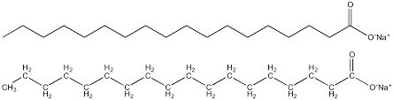 sodium stearate

- Write a generalised equation for
- formation of an ester (triglyceride) from palmitic acid C₁₅H₃₁COOH with 1,2,3-propantriol

- saponification of this ester.

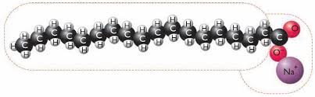
- The soap molecule produced is a positive sodium ion attached to a negative carboxyl group, which is attached to a very long carbon chain.
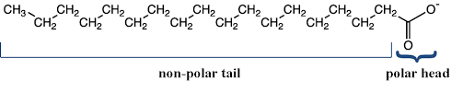
- The sodium salt is soluble in water.
- When dissolved, the soap ion has a non-polar hydrocarbon chain and a polar carboxylate group.

Formation of a detergent: Sodium dodecylbenzene sulfonate

- Detergents are produced by the action of sulphuric acid on an alkyl benzene molecule (a by product of the petroleum industry) followed by sodium hydroxide.

- The result is a salt of a benzene sulphonic acid.
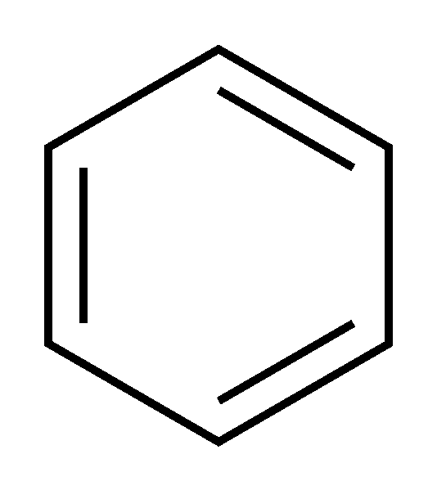

CH₃(CH₂)₁₁―

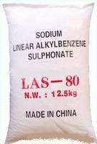
Concentrated H₂SO₄


O
║
CH₃(CH₂)₁₁― ―S ― H + H₂O
║
O

Solution NaOH

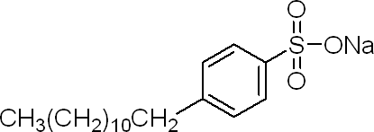

+ H₂O

Sodiumdodecyl benzene sulfonate (an alkylbenzene sulfonate)

- The sodium salt is soluble in water.
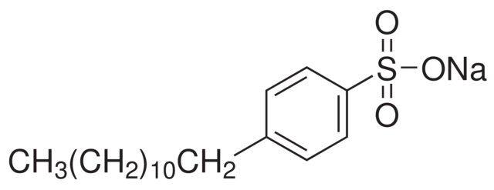

- When dissolved, it produces an ion with a long, non-polar hydrocarbon chain and a polar sulfonate group.

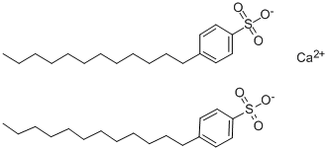

PC 16.2 p 438-43 16.2 Review p 444 EC 12.5 p136
The cleaning action of soaps and detergents can be explained in terms of their non-polar hydrocarbon chain and charged group; the properties of soaps and detergents in hard water can be explained in terms of the solubilities of their calcium salts.

Cleaning Agents

  - These include soaps and detergents.
    - They are known as surfactants (surface acting) or ‘wetting’ agents.
    - They act as emulsifying agent.
      - Emulsifying agents are substances that can keep two normally immiscible substances in the same phase (e.g. soap keeps oil dissolved in water).

- Soaps and detergents are salts of fatty acids.
  - They are soluble in water and produce a cation and a long chained fatty acid.
  - The cation (Na of K) does not take place in any reactions.

- The fatty acid section has a non-polar end which
      - is a long hydrocarbon chain
      - is attracted to non-polar grease and oil by dispersion forces
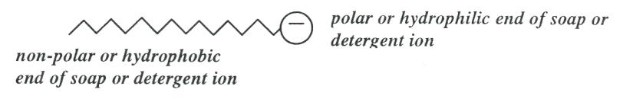

- It also have a polar end which
- is the ionic part of the molecule
- is attracted to the water molecules by hydrogen bonding forces

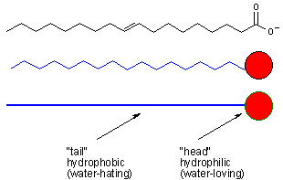

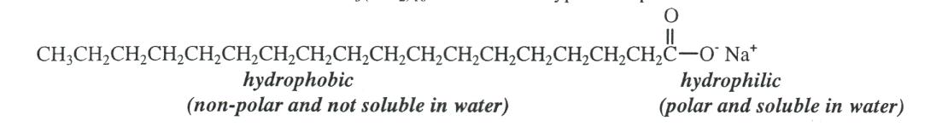
sodium stearate soap

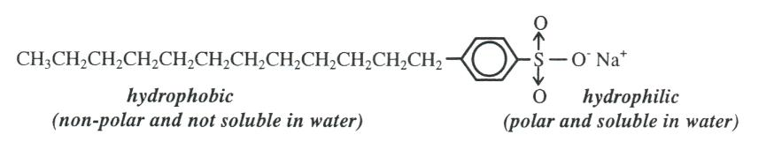
sodium dodecylbenzenesulphonate detergent

  - Soaps and detergents have a cleaning action by allowing water-insoluble materials to be removed from the surface to which they adhere.
  - The polar end attracts the water and the non-polar end attracts the oil or dirt.
    - Dirt (oil, grease stains etc) is non-polar and also insoluble in water.
    - The non-polar tails bury themselves in the dirt
  - The oil or dirt is agitated and lifts off the surface to produce a micelle.
    - The dirt is captured inside the micelle.
    - The micelle acts like a polar substance and mixes readily with the water.

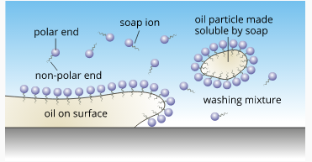

Hard water

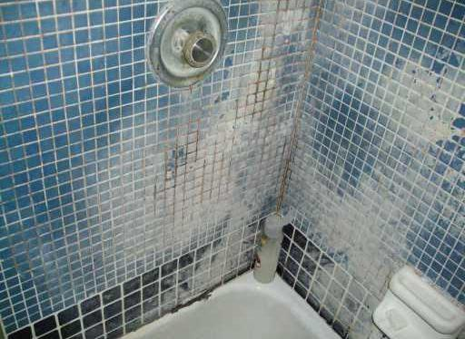

  - Soaps have a significant disadvantage.
  - Soaps can form a scum in hard water (containing Ca²⁺_{(aq)}, Fe²⁺_{(aq)} or Mg²⁺_{(aq)})
  - The scum is an insoluble precipitate

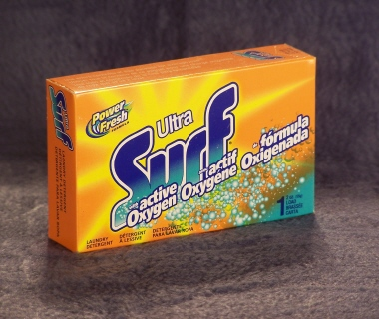
  - Detergents do not from a scum as the potential products in hard water are soluble. Replacing the carboxylate (COO⁻) with sulfonate (SO₃⁻) provides an effective surfactant that would not produce scum in hard water.

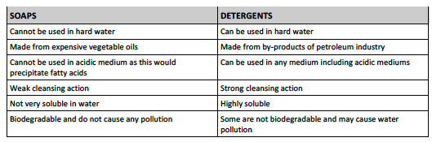

PC 16.3 p 445 16.3 Review p 446 Chapter review p 454-6 EC 12.6 p136-7

Industry produces a vast range of plastics, including addition polymers (polyethene, polytetrafluoroethene) and condensation polymers (nylon and polyethylene terephthalate [PET]) which have different properties and uses.

Addition Polymers

- Polymers consist of many chains of varying lengths (and thus molecular mass) that interact through dispersion forces.
- Depending on conditions, the addition polymer chain can form a:
  - Predominantly linear chain with high molecular mass and little branching – chains are able to approach closer to one another and thus dispersion forces are strong.
  - Chains with large amounts of branching – much weaker dispersion forces.

- Properties of the addition polymers can be changed by increasing the branched side chains on the polymer chain. The more branched present, the weaker the dispersion forces between the molecules.

Monomer | Polymer | Properties | Uses
Ethene  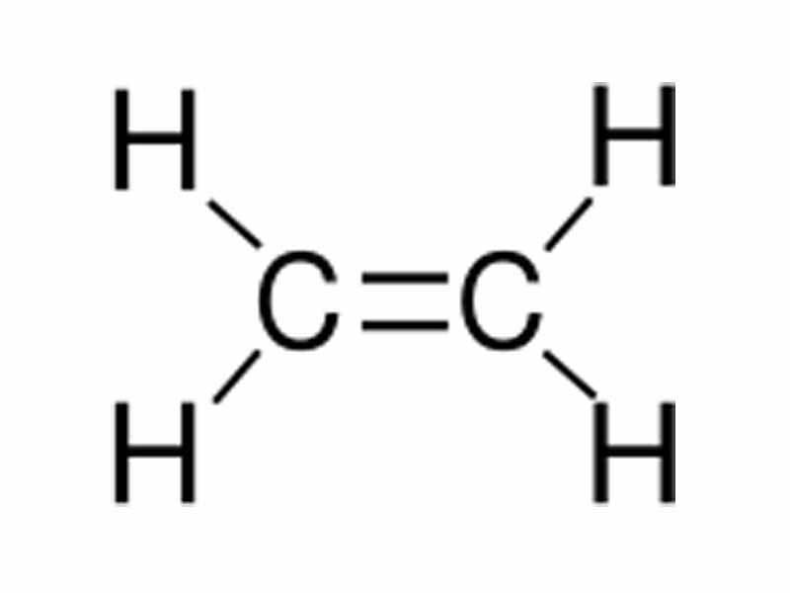 | Polyethene  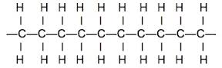 | flexible, cheap, electrical insulator | plastic bags and bottles, coating on electrical wires | 
Propene  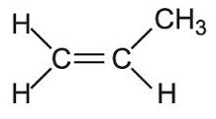 | Polypropene  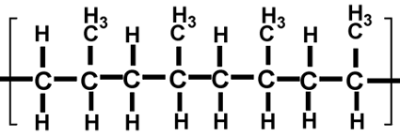 | flexible and strong | buckets and crates | 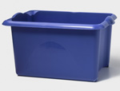
Chloroethene  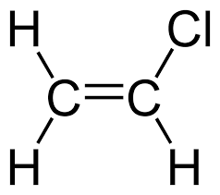 | Polychloroethene PVC  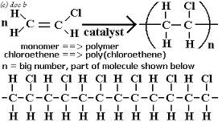 | tough, cheap and long lasting | window frames, pipes | 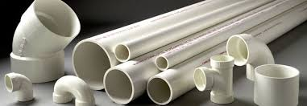
Tetrafluoroethene  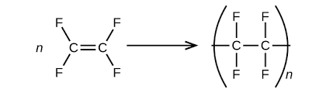 | Polytetrafluoroethene PTFE  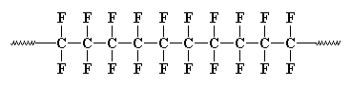 | tough and non-stick | non-stick coating on pans | 

EC p148

Condensation Polymers

Monomer | Polymer | Properties | Uses
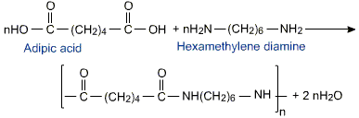  +   | Nylon  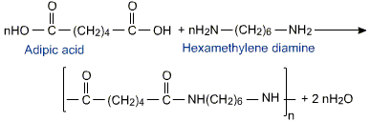 | lustrous, durable, high elongation, abrasion resistant, resilient to heat | seatbelts, tire cords, ballistic cloth, parachute material, fishinh nets, ropes | 
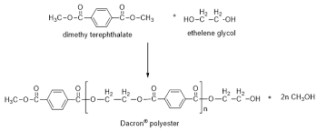  +  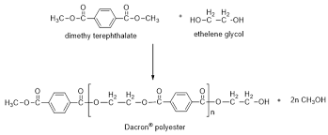 | Dacron  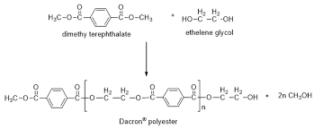 | high tensile strength, stretch resistant, resistant to  degradation by chemical bleaches and to abrasion. | curtains, dress fabrics, high-pressure fire hoses, men's shirts, and thread. | 
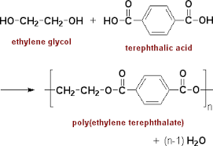  +   | Polyethylene terephthalate PET  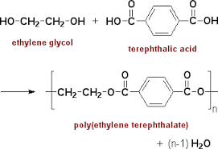 | hard, stiff, strong, stable material that absorbs very little water, chemical resistance | packaging foods and beverages, especially convenience-sized soft drinks, juices and water. | 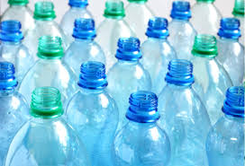

Properties, uses and structure

- Crystallinity
  - Molecules of linear polymers can tangle up.
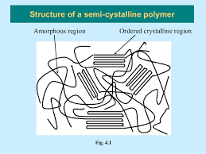
  - Crystalline areas form when intermolecular forces are strong. These areas have greater rigidity and higher melting points.
  - Amorphous regions are created when the polymer chains are tangled. These create large gaps with weak intermolecular forces. These areas are more flexible with lower melting points.
  - The degree of crystalline and amorphous regions can be controlled to alter the properties of the polymer.

- Branching
  - Chains with little or no branching can pack close together.
  - They will be more crystalline, more dense, less transparent and less flexible.
  - Chains with more branching will be more amorphous.

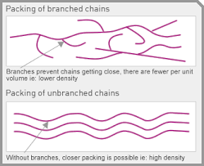


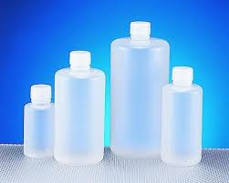
HDPE LDPE
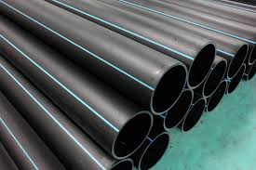

- Chain length
  - In general, the longer the chain, the higher the melting point and the harder the polymer is.

- Side groups
  - Replacing H in a chain with a side group can reduce the flexibility of a polymer and make it stiffer.
  - Replacing H in polyethene
    - with Cl produces PVC.
    - with benzene produces polystyrene.

Polyethene Polyvinyl chloride PVC Polystyrene

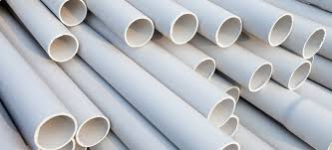
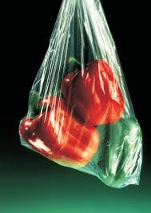
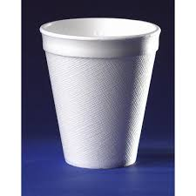

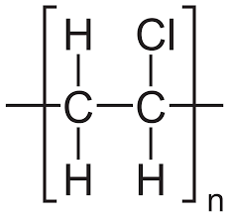
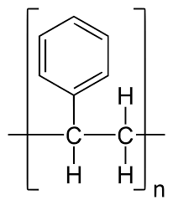

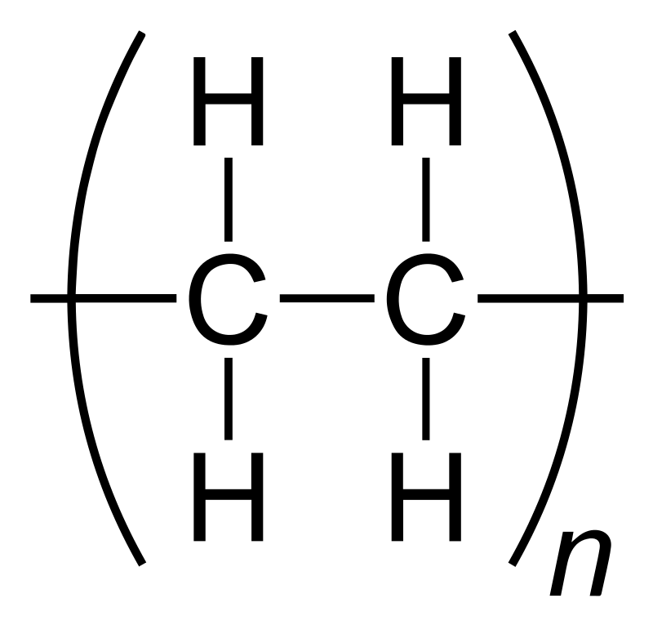

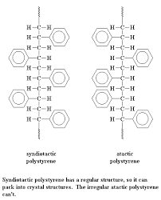
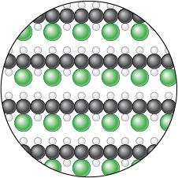

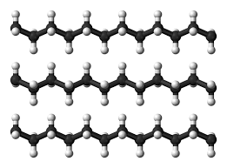

- Cross-linking
  - Linear chains are linked with strong covalent or ionic bonds between the chains.
  - Makes the polymer more rigid.

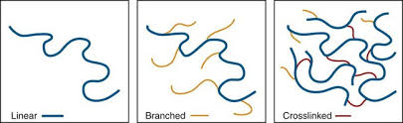
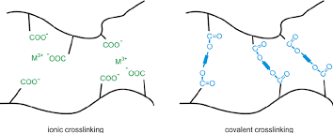

PC Chapter 15
Unit 4 Review Questions p 545-9

Problem Set 1 p
1. Several experiments are described below. In each case a chemical reaction will occur. Write a balanced molecular equation to show this can give a short description of what you would expect to observe as the reaction occurs.
- Excess HNO₃ _{(aq)} solution is added to solid Fe₂(CO₃)₃.
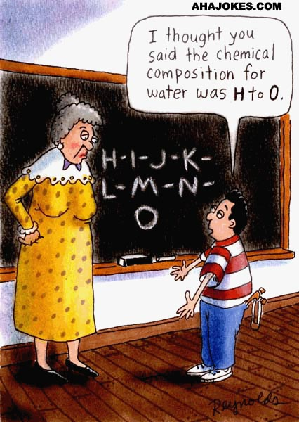
6HNO_{3 (aq)} + Fe₂(CO₃)_{3 (s)} → 2Fe(NO₃) _{(aq)} + 3CO_{2 (g)} + 3H₂O_{(l)}
colourless, odourless gas evolves
- Granule of calcium oxide is treated with excess HCl _{(aq)} solution.
2HCl_{(aq)} + CaO _{(s)} → CaCl_{2 (aq)} + H₂O_{(l)}
Solid dissolves to colourless solution, exothermic reaction
- Excess HNO₃ _{(aq)} solution is added to a iron (II) hydroxide suspension.
2HNO_{3 (aq)} + Fe(OH)_{2 (s)} → Fe(NO₃)_{2 (aq)} + 2H₂O_{(l)}
solid dissolves into pale green solution
- Dilute KOH _{(aq)} is added to an NH₄NO₃ _{(aq)} solution.
KOH_{(aq)} + NH₄NO_{3 (aq)} → KNO_{3 (aq)} + H₂O_{(l)} + NH_{3 (g)}
colourless solutions mixed to produce colourless, pungent gas
- Some 2.0 mol L⁻¹ sulphuric acid is added to solid iron metal.
H₂SO_{4 (aq)} + Fe_{(s)} → FeSO_{4 (aq)} + H_{2 (g)}
solid dissolves into green solution, colourless, odourless gas evolves
- Solid calcium hydroxide pellets are added to excess phosphoric acid.
3Ca(OH)_{2 (s)} + 2H₃PO_{4 (aq)} → Ca₃(PO₄)_{2 (s)} + 6H₂O_{(l)}
Colourless solution added to white solid produces white ppt.
- Solid potassium sulfite granules are added to a hydrochloric acid solution.
K₂SO_{3 (s)} + 2HCl_{(aq)} → 2KCl _{(aq)} + H₂O_{(l)} + SO₂
white solid plus colourless solution produces colourless, choking (pungent) gas
- Concentrate ethanoic acid is added to solid nickel (II) carbonate.
2CH₃COOH_{(aq)} + NiCO_{3 (s)} → Ni(CH₃COO)_{2 (aq)} + CO_{2 (g)} + H₂O_{(l)}
green solid dissolves to form green solution, colourless, odourless gas evolved
- Sulfur dioxide gas is bubbled through a potassium hydroxide solution.
SO_{2 (g)} + 2KOH_{(aq)} → K₂SO_{3 (aq)} + H₂O_{(l)}
Colourless pungent gas dissolves to produce colour solution; exothermic
- Sulfur trioxide gas is passed through a barium hydroxide solution.
SO_{3 (g)} + Ba(OH)_{2 (aq)} → BaSO_{4 (s)} + H₂O_{(l)}
colourless gas dissolves in colourless solution; exothermic;white ppt
- Aluminium is added to a solution containing excess sulfuric acid.
2Al_{(s)} + 3H₂SO_{4 (aq)} → Al₂(SO₄)_{3 (aq)} + 3H_{2 (g)}
silver metal dissolves in colourless solution, colourless, odourless gas evolves.
- Most of the following experiments will result in a chemical change. Where this is expected write a balanced net ionic equation that shows this. Also describe any observable changes you would expect to see during the progress of the reaction. If no change is expected write no reaction.

- Powder CuO is added to a H₂SO₄ solution.
CuO_{(s)} + 2H⁺_{(aq)} → Cu²⁺_{(aq)} + H₂O_{(l)}
black solid dissolves to form blue solution
- A barium hydroxide solution is added to a copper (II) carbonate suspension.
Ba(OH)₂ _{(aq)} + CuCO_{3(s)} BaCO_{3(s)} + Cu(OH)_{2(s)}

- Sulphur dioxide gas is bubbled through a potassium hydroxide solution.
SO_{2 (g)} + 2OH⁻_{(aq)} → SO₃²⁻_{(aq)} + H₂O_{(l)}
pungent colourless gas dissolves to form colourless solution
- Powdered ammonium nitrate is added to excess sodium hydroxide solution.
NH₄NO_{3 (s)} + OH⁻_{(aq)} → NO₃⁻_{(aq)} + H₂O_{(l)} + NH_{3 (g)}
white solid dissolves to produce colourless solution and pungent gas evolves
- Powder calcium hydroxide is added to a concentrated sodium hydroxide solution.
No visible reaction
- A sodium sulfite solution is added to a nitric acid solution.
SO₃²⁻_{(aq)} + 2H⁺_{(aq)} → H₂O_{(l)} + SO_{2 (g)}
colourless solutions mixed to produce pungent colourless gas
- Granulate zinc is added to hydrochloric acid.
Zn_{(s)} + 2H⁺_{(aq)} → Zn²⁺_{(aq)} + H_{2 (g)}
silver solid dissolves to produce colourless solution, colourless, odourless gas
evolves
- A sulfuric acid solution is added to a copper (II) hydroxide suspension.
2H⁺_{(aq)} + Cu(OH)_{2 (s)} → Cu²⁺_{(aq)} + 2H₂O_{(l)}
blue solid dissolves to produce clear blue solution
- A hydrochloric acid solution is added to powdered aluminium oxide.
6H⁺_{(aq)} + Al₂O_{3 (s)} → 2Al³⁺_{(aq)} + 3H₂O_{(l)}
white solid dissolves to produce colourless solution
- Carbon dioxide gas is bubbled through a sodium hydroxide solution.
CO_{2 (g)} + 2OH⁻_{(aq)} → CO₃²⁻_{(aq)} + H₂O_{(l)}
colourless, odourless gas dissolves producing colourless solution
- Magnesium ribbon is added to an ethanoic acid solution.
Mg_{(s)} + 2H⁺_{(aq)} → Mg²⁺_{(aq)} + H_{2 (g)}
silver metal dissolves in colour solution, colourless, odourless gas evolves
- Ammonium chloride solution is added to a barium hydroxide solution.
NH₄⁺_{(aq)} + OH⁻_{(aq)} → H₂O_{(l)} + NH_{3 (g)}
colourless solutions mixed, colourless, pungent gas evolves, solutions colourless
- Copper turnings are added to a hydrochloric acid solution.
No reaction

- A sulfuric acid solution is added to marble chips (CaCO₃).
CaCO_{3 (s)} + 2H⁺_{(aq)} → Ca²⁺_{(aq)} + CO_{2 (g)} + H₂O_{(l)}
white solid dissolves in colourless solution, colourless, odourless gas evolves
- Ammonia gas is bubbled through a hydrochloric acid solution.
NH_{3 (g)}+ H⁺_{(aq)} → NH₄⁺_{(aq)}
pungent, colourless gas dissolves into colourless solution
- Solid copper (II) carbonate is added to a nitric acid solution.
CuCO_{3 (s)} + 2H⁺_{(aq)} → Cu²⁺_{(aq)} + CO_{2 (g)} + H₂O_{(l)}
blue/green solid dissolves in colourless solution, colourless, odourless gas evolves

- The table shows observations recorded when tests are carried out on four samples of a solution. Use these results to deduce the ions present. Support your deduction with an ionic equation.
Test | Result | Ions present and equation
add KI | Yellow ppt | yellow ppt common for PbI₂ so lead ions  Pb²⁺_{(aq)} + 2I⁻_{(aq)} → PbI_{2 (s)}
Add drops of OH⁻ | Blue ppt | blue ppt common of copper so copper ions present  Cu²⁺_{(aq)} + 2OH⁻_{(aq)} → Cu(OH)_{2 (s)}
Add AgNO₃ | white ppt that darkens on exposure to light | darkening white ppt common of silver chloride so chloride ions  Ag⁺_{(aq)} + Cl⁻_{(aq)} → AgCl_{(s)}
Add dilute HCl | gas produced that turns limewater milky | produced gas is CO₂ which needs carbonate or hydrogencarbonate ions  CO₃²⁻_{(aq)} + 2H⁺_{(aq)} → H₂O_{(l)} + CO_{2 (g)}

Problem Set 2

- A few drops of dilute sodium hydroxide solution is added to the following. Does a precipitation reaction occur in any of these situations? If a reaction is expected write a net ionic equation to show this and describe any observation you would expect.

- SnCl₂ _{(aq)} Sn²⁺_{(aq)} + 2OH_{(aq)} → Sn(OH)_{2 (s)}
two colourless solutions combine and turn cloudy as a white ppt forms
- Na₂SO₄ _{(aq)}
No reaction
- barium chloride solution
No reaction
- Fe(NO₃)₃ _{(aq)} Fe³⁺_{(aq)} + 3OH⁻_{(aq)} → Fe(OH)_{3 (s)}
Pale brown solution turns cloudy as a pale brown ppt forms

- copper (II) sulfate solution Cu²⁺_{(aq)} + 2OH⁻ _{(aq)} → Cu(OH)_{2 (s)}
blue solution turns cloudy as blue ppt forms

- nickel (II) nitrate solution Ni²⁺_{(aq)} + 2OH⁻ _{(aq)} → Ni(OH)_{2 (s)}
green solution turns cloudy as green ppt forms


- The following ionic solutes may or may not be soluble. Where soluble, write dissociation equations to show how they dissolve to form aqueous solutions.

- FeCl_{2 (s)}
FeCl_{2 (s)} → Fe²⁺_{(aq)} + 2Cl⁻_{(aq)}
- MgCO_{3 (s)}
insoluble
- Ba(OH)_{2 (s)}
Ba(OH)_{2 (s)} → Ba²⁺_{(aq)} + 2OH⁻_{(aq)}
- (NH₄)₃PO_{4 (s)}
(NH₄)₃PO_{4 (s)} → 3NH₄⁺_{(aq)} + PO₄³⁻_{(aq)}
- Ca(OH)_{2 (s)}
slightly soluble Ca(OH)_{2 (s)} → Ca²⁺_{(aq)} + 2OH⁻_{(aq)}

- Using precipitation reactions and reagents of your choosing show how to distinguish each substance in the following groups of three compounds. You will need to explain your process in written form or by using a flow diagram. You may need to perform more than one test for each group of unknowns. Remember, to perform a precipitation reaction, the substance tested must first be in solution.

NB: there are other methods than the ones listed below.

  - Na₂SO_{4 (s)}, Na₂CO₃ _{(s)} and NaOH_{(s)}

    - add HCl: from Na₂CO₃ a colourless, odourless gas will evolve
    - add Ba(NO₃)_{2 (aq)}: BaSO₄ is insoluble but Ba(OH)₂ is soluble

  - Pb(NO₃)_{2 (s)}, Fe(NO₃)_{2 (s)} and Mg(NO₃)_{2 (s)}

- add KI: Pb(NO₃)₂ will produce a yellow ppt, others are soluble
- add Na₂CO₃: FeCO₃ will produce a green ppt but Mg(NO₃)₂ a white ppt

Problem Set 3 (Answers)

1. a) 2C + O₂ 2CO
Fe₂O₃ + 3CO 2Fe + 3CO₂
x3 6C + 3O₂ 6CO
x2 2Fe₂O₃ + 6CO 4Fe + 6CO₂
6C + 3O₂ + 2Fe₂O₃ 4Fe + 6CO₂
- m(Fe₂O₃) = 35.0 x 3.00 x 10⁶ = 1.050 x 10⁶ g
100
n(Fe₂O₃) = m = 1.050 x 10⁶ = 6.575 x 10³ mol
M 159.7
n(C) = 6/2 x n(Fe₂O₃) = 3 x 6.575 x 10³ = 1.972 x 10⁴ mol
m(C) = nM = 1.972 x 10⁴ x 12.01 = 2.37 x 10⁵ g

2. a) NH₄NO₂ N₂ + 2H₂O
n(NH₄NO₂) = m = 153.5 = 2.3965 mol
M 64.052
n(N₂) = 1/1 x n(NH₄NO₃) = 2.3965 mol
n(H₂O) = 2/1 x n(NH₄NO₃) = 4.7929 mol
V(N₂) = nRT = 2.3965 x 8.314 x 393.15 = 87.04 L
P 90
V(H₂O) = nRT = 4.7929 x 8.314 x 393.15 = 174.07 L or V(H₂O) = 2 x V(N₂)
P 90 = 174.07 L
V_{Total} = 87.04 + 174.07 = 261 L
      - n(N₂) = 2.3965 mol
At STP V(N₂) = n x 22.71 = 2.3965 x 22.71 = 54.4 L

- a) n(CdC₂O₄) = m = 0.501 = 2.4997 x 10⁻³ mol
M 200.42
n(Cd²⁺) = n(CdC₂O₄) = 2.4997 x 10⁻³ mol
m(Cd²⁺) = nM = 2.4997 x 10⁻³ x 112.4 = 0.28097 g

ppm = m(solute) x 10⁶ = 0.28097 x 10⁶ = 562 ppm
m(solution) 500
c(Cd²⁺) = n = 2.4997 x 10⁻³ = 5.00 x 10⁻³ M
V 0.500
  - CdS + H₂ H₂S + Cd
n(H₂S) = V = 0.0560 = 2.4659 x 10⁻³ mol
22.71 22.71
n(Cd²⁺) = n(H₂S) = 2.4659 x 10⁻³ mol
m(Cd²⁺) = nM = 2.4659 x 10⁻³ x 112.4 = 0.27716 g
ppm = m(solute) x 10⁶ = 0.27716 x 10⁶ = 554 ppm
m(solution) 500
c(Cd²⁺) = n = 2.4659 x 10⁻³ = 4.93 x 10⁻³ M
V 0.500

  - Results are within 2% of each other, therefore consistent.

4. a) 2C + O₂ 2CO
Fe₂O₃ + 3CO 2Fe + 3CO₂
x3 6C + 3O₂ 6CO
x2 2Fe₂O₃ + 6CO 4Fe + 6CO₂
6C + 3O₂ + 2Fe₂O₃ 4Fe + 6CO₂

b) m(Fe₂O₃) = 93.0 x 10⁶ = 930 000 g
100
n(Fe₂O₃) = m = 930 000 = 5823.4 mol
M 159.7
n(C) = 6/2 x n(Fe₂O₃) = 3 x 5823.4 = 17 470 mol
m(C) = nM = 17 470 x 12.01 = 2.20 x 10⁵ g

  - m(SiO₂) = 7 x 1000 000 = 70 000g
100
n(SiO₂) = m = 70 000 = 1165 mol
M 60.09
n(CaCO₃) = n(SiO₂) = 1165 mol
m(CaCO₃) = nM = 1165 x 100.09 = 1.17 x 10⁵ g

5. a) Ca₃(PO₄)₂ + 3H₂SO₄ 2H₃PO₄ + 3CaSO₄
2H₃PO₄ + 2NH₃ 2(NH₄)₂HPO₄

n[(NH₄)₂HPO₄] = m = 46 120 = 349.2 mol
M 132.062
n(Ca₃(PO₄)₂) = ½ x n[(NH₄)₂HPO₄] = 174.6 mol
m(Ca₃(PO₄)₂) = nM = 174.6 x 310.18 = 54.157 kg
% purity = m(Ca₃(PO₄)₂) x 100 = 54.157 = 90.3%
m(rock phosphate) 60.0

b) n(NH₃) = 2/1 x n[(NH₄)₂HPO₄] = 698.5 mol
V(NH₃) = n x 22.71 = 698.5 x 22.71 = 15 862 L
given 10% escape, need 10% extra (90% efficient)
i.e. V(NH₃) = 15 862 x 100 = 17.6 kL
90

